2.5.4 Real-Time Documents on Read The Docs Feasibility Study

What is Read The Docs?

Read The Docs is a free and complete document hosting service.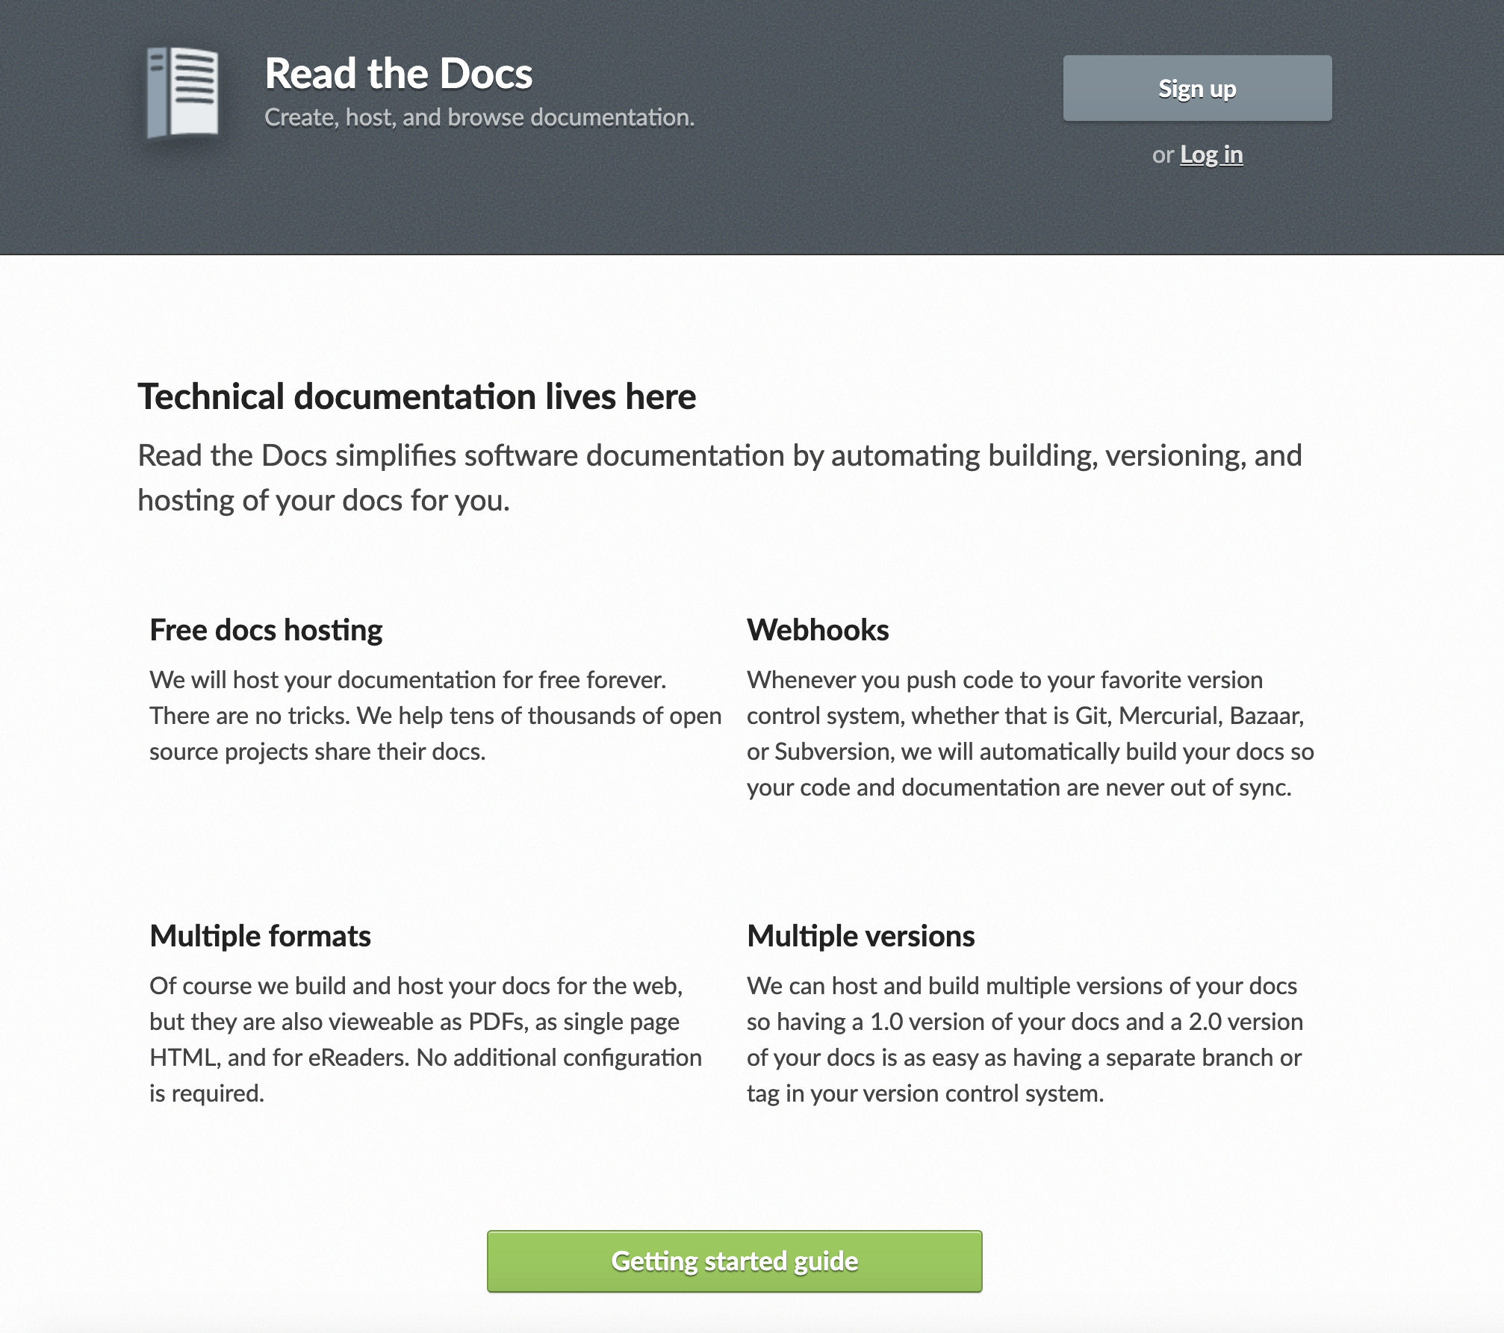

Concept of Operations

# Use RTD as the primary documentation service for real time documentation

## RTD would provide the following benefits

* Host real time documentation on a public website
* Complete search facility for all hosted documentation
* Version control
* Format conversions
* Unified appearance

## Potential documents that could be hosted on RTD

* ADE Documentation
* ADE 2 Documentation
* Use Cases and requirements for ADE systems (Google docs)
* SW Development standards (DMT)
* CCB Functional Requirements
* Release notes
* VME boot/info/settings
* Instructions/How-Tos

# Steps to use RTD for real time documentation

## Migrate existing real time documents to RTD

* 1. Compile complete list of documents
  2. Convert documents
  3. Verify conversions
  4. Add to repos
  5. Publish to RTD

## Using RTD for new real time documents

* 1. Learn to write rst
  2. Write documentation
  3. Add to repos
  4. Publish to RTD

Gemini RTD Experiments

# Read The Docs Workflow

Figure 1



# 

# 

# RTD Experiment Team

5 engineers 40 hours

# Conversion Examples

## Gemini ADE conversion from PDF to rst and published on RTD



## Gemini Record Reference Manual



# Results

## PDF

Most PDF conversions are fine without any modifications and can be directly uploaded to RTD. However, many technical drawings and graphics in PDFs do not convert properly and would either need to be manually redrawn. Another option would be to link PDFs that do not convert properly.

## WikiHTML

Wiki/HTML conversions generally work without issues. Some minor formatting issues did arise from the Wikis that required manual fixes. Tables of contents did not always convert properly.

## Google Docs and Word documents

Google Docs and Word (docx) documents generally converted without any issues. Graphics and images occasionally need to be fixed.

# Feedback from engineers

Initial resistance to learning new system

General positive feedback

Comments to use RTD tools and hosting locally

Using Read The Docs with existing Gemini Documents

# Training

RTD uses rst markup language. Rst is relatively easy to use, however, rst is not intuitive. A short training for engineers using RTD would save time in the long run. A 1 to 2 hour introduction to rst and RTD would be a good start.

# Searching

RTD provides a standardized hosting and search environment. Gemini will still have documentations located in different locations, however,

# Collaboration

Collaboration on Google docs is hard to beat. docs is a better option for live documents.

# Time Saving

Implementation Estimate

Read The Docs work unit estimates

|  |  |  |  |  |
| --- | --- | --- | --- | --- |
| Unit | Description | Time (hours) | Quantity | Estimate (hours) |
| Create/update repo | Create a new Git or SVN repo to hold docs or add docs to an existing repo. | 0.1 | 10 | 1 |
| List/find all real time docs |  | 8 | 1 | 8 |
| Convert pdf | Convert PDF docs using pandoc and Word. Check docs for accurate and usable conversion. | 0.25 | 100 | 25 |
| Convert doc | Convert Good Docs using pandoc. Check docs for accurate and usable conversion. | 0.1 | 100 | 10 |
| Convert Wiki/HTML | Convert Wiki/HTML docs using pandoc. Check docs for accurate and usable conversion. | 0.15 | 100 | 15 |
| Write documents | Write new rst documents. | 0.01 | 100 | 1 |
| Create automation scripts | Create scripts to automatically convert large resources of documents. | 16 | 1 | 16 |
| Publish | Push docs to RTD and check for finished build. | 0.01 | 10 | 0.1 |
| Create Training Material | Create instructions and how-tos for basic rst and RTD use cases | 16 | 1 | 16 |
| Misc. administration | Meetings, mail, organization, communication, etc. | 8 | 1 | 8 |
| Contingency |  | 20 | 1 | 20 |
| Implementation Estimate (hours) | | | | 120.1 |

